**Please write a “Google review” for** [**YOUR**](https://plus.google.com/102697255111103589535/about) **BUSINESS NAME GOES HERE**

(takes ~3 minutes)

**Do you have a**  [**Google Plus**](https://plus.google.com) **page?**

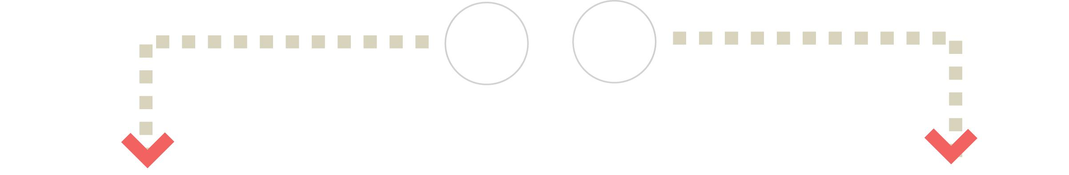

**No /**

**Don’t** **Yes**

**Know**

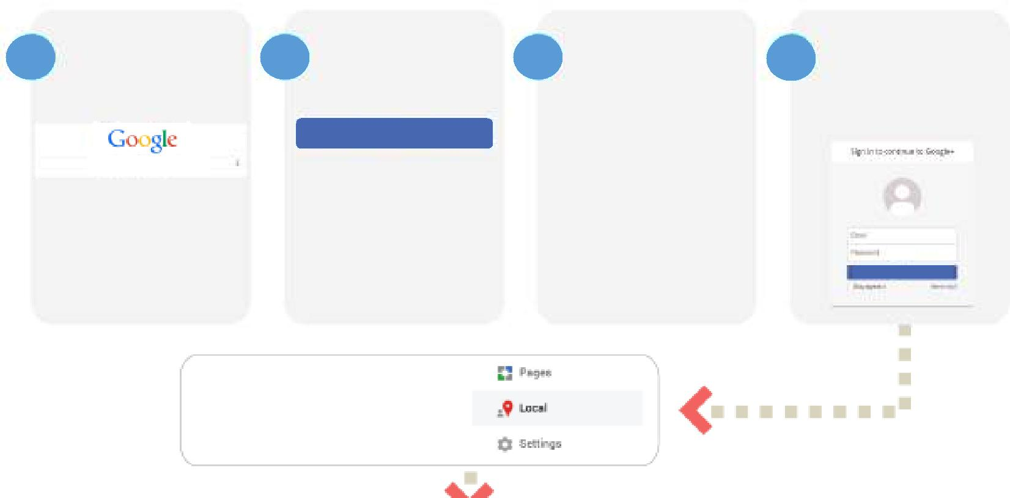

|  |  |  |  |  |
| --- | --- | --- | --- | --- |
| **1** | Go to Google | **2** | Fill in the fields |  |
| and type in | on the right, |  |
|  | [“plus.google.com](https://plus.google.com)” |  | then click “Next Step” |  |

**Next Step**

[plus.google.co](https://plus.google.com)m

Then click

“Create an account”. If you already have a Google account, simply log in.

Hover over the “Home” button in the top left,

then click on the “Local” button.

|  |  |  |  |  |
| --- | --- | --- | --- | --- |
| **3** | Google will ask you to | **4** | Sign into your |  |
| add a bunch of details | [Google Plus](https://plus.google.com) page |  |
|  | to your profile, but *feel* |  | (if you’re not |  |
|  | *free to skip these* |  | already signed in). |  |
|  | *steps* until you’re on |  |  |  |
|  | your Plus page. |  |  |  |

**Sign In**



Type in the name of our business, city, and state, then click the “search” button.

NAME OF YOUR BUSINESS CITY, STATE



|  |  |  |  |  |  |
| --- | --- | --- | --- | --- | --- |
| Next, click on the little | | | Please rate us however many | Finally, click on the |  |
| “Write a review” pencil. | | | “stars” you’d like and jot down a | “Publish” button. |  |
|  |  |  | review of your experiences with us. |  |  |
|  |  |  |  |  |
|  |  |  |  |  |  |

**You’re done. Thanks for your review.**

YOUR BUSINESS NAME HERE **(xxx) xxx-xxxx yourdomain.com**

**OR INSERT IMAGE HERE**